Beginner Linux Challenges

Task 5
- - 3. : Please see figure 1
figure 1
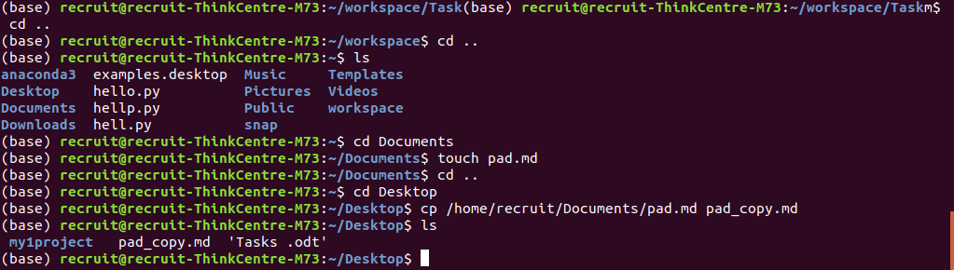
4. - 6. Please see figure 2
figure 2
